Macintosh HD:private:var:folders:qq:50cp4n9s5fqgtk0h4bp6d_v80000gq:T:TemporaryItems:octavian logo on white.eps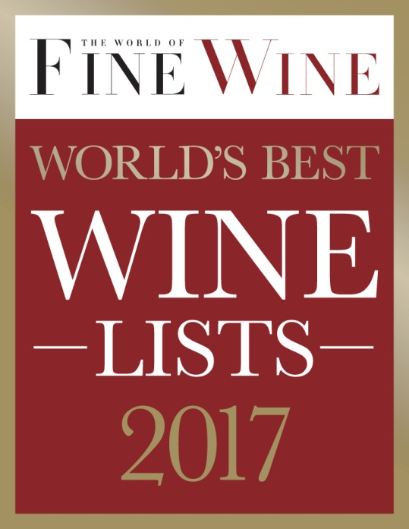

(INSERT RESTAURANT NAME) has been awarded a prestigious one-star award in The World of Fine Wine World’s Best Wine Lists 2017, in association with Octavian Wine Vaults.

The fourth annual “World’s Best Wine Lists” have been announced with Palais Coburg in Austria receiving the honor of the “Champions’ League Best Overall Wine List”, and Rouge Tomate Chelsea in New York claiming “Wine List of the Year”, and the “Best Long Wine List in the World”.

The awards are assessed by a panel of judges containing some of the world’s leading sommeliers and wine writers, including Alder Yarrow, Elin McCoy, Ch’ng Poh Tiong, Andrew Jefford, Andreas Larsson, Francis Percival, and The World of Fine Wineeditor Neil Beckett.

The judges surveyed well over 4,500 wine lists from restaurants around the world before finalizing the list of 997 one-, two-, and three-star restaurants. Only 242 restaurants were recognized for the esteemed one-star award.

All the finalists in the World’s Best Wine Lists must reach certain standards in relation to a range of criteria, among which the most important are: the breadth, depth, interest, quality, and value of the wine selection (relative to the nature and size of the list and any specialism). A one-star award recognizes a good wine list in line with the general criteria.

Since initiating in 2014, the awards have gone from strength to strength, and are “rapidly becoming as coveted as Michelin Stars,” according to former World Sommelier Champion Gerard Basset MS MW OBE.

On the awards, The World of Fine Wine editor Neil Beckett commented “This year we saw the strongest level of entries yet, in terms of both quality and quantity, and the introduction of the Champions’ League and exciting new categories such as Best Regional List and Best Spirits List are a reflection of the rise in standards in wine programs all over the world.”

For the full list of winners please visit <http://www.worldoffinewine.com/subject/about-winelistawards>

**- ENDS -**

**Notes to editors**

The World’s Best Wine Lists is the most prestigious and rigorous wine list awards, judging over 4,500 restaurants lists worldwide. Each year the awards highlight prominent wine lists in wine establishments around the world. World of Fine Wine assembled a panel judges to assess each list to guarantee the credibility and integrity of the competition and to put each submitted list through an intensive judging process.

In 2017 the awards judging panel contained some of the world's leading critics and masters of wine from around the globe including Alder Yarrow, Elin McCoy, Anne Kriebiehl MW, Ch'ng Poh Tiong, Andrew Jefford, Andreas Larsson, Francis Percival, Luciana Girotto, and chaired by WFW editor Neil Beckett.

All award-winning wine lists must reach certain standards in relation to a range of criteria, among which the most important are: the breadth, depth, interest, quality, and value of the wine selection (relative to the nature and size of the list and any specialism); the clarity of the organization and presentation; the accuracy and completeness of the information for each entry on the list, including origin, producer, wine, vintage, price, and format or serving size; the suitability of the selection in terms of the cuisine and the establishment.

Find out more about the World's Best Wine Lists [here](http://www.worldoffinewine.com/subject/about-winelistawards).

**About Octavian Wine Vaults**  
  
[Octavian Wine Vaults](http://www.octavianvaults.co.uk/) is the finest wine cellarage service you will find, and is brought to you by Octavian. Octavian has been delivering fine wine storage excellence for more than 20 years. Our expertise is trusted by the leading wine merchants, wine funds, and restaurants, as well as by 10,000 collectors worldwide. We take the time to understand the needs of our customers, and offer them tailor-made services. We have built an impeccable reputation by caring for our customers' assets as if they were our own - it is a reputation we are proud to have achieved. It is this commitment that drove us to develop the world's leading fine wine storage facility. Winemakers to wine lovers, investors to auctioneers - they all know that a wine cared for at Octavian's Corsham Cellars is without equal. The Octavian Vaults service is delivered by our expert team at Corsham Cellars - a very special place, lying 100 feet below the hills of Wiltshire. Encased in solid Bath stone, it is an ideal facility for the cellaring of fine wine. Our attention to detail has rewarded us with an unrivalled reputation and considerable success. The next 20 years will be built on ongoing investment in our storage facilities and continued commitment to our customers.

**Media Contact**

Katherine Houston

[Katherine.houston@worldoffinewine.com](mailto:Katherine.houston@worldoffinewine.com)

T: +44 (0)20 3096 5703